2320090004

G.LAVANYA

Sec - 4

**Data Science and Statistics Tutorial**

* **Probability of Addition:**

The Addition Rule of Probability is used to find the probability that either of two events, Aor B, will happen. It is especially useful when events may overlap.

**General Addition Rule:**

P(A∪B) = P(A) + P(B) − P(A∩B)

**Example in Mathematical –**

Q. In a class of 50 students:

30 students like Mathematics.

25 students like science.

10 students like both Mathematics and Science.

If a student is chosen at random, what is the probability that the student likes Mathematics or Science?

Answer:

* Event A = student likes Mathematics → P(A) = 30 / 50 = 0.6
* Event B = student likes Science → P(B) = 25 / 50 = 0.5
* Event A ∩ B = student likes both → P(A∩B) = 10 / 50 = 0.2

Now apply the **Addition Rule**:

P(A∪B) =P(A)+P(B)−P(A∩B)

P(A∪B) =0.6+0.5−0.2=0.9

**Example in programming –**

**Output –**

* **Probability of Multiplication –**

The Multiplication Rule is used to find the probability that two events A and B both occur, i.e., the probability of A ∩ B (A *and* B).

**For Independent Events:**

If A and B are independent, then:

P(A∩B) = P(A) × P(B)

**For Dependent Events:**

If A and B are dependent, then:

P(A∩B) = P(A) × P(B∣A)

**Example in Mathematics –**

Q. A coin is tossed, and a die is rolled. What is the probability of getting a Head on the coin and a 4 on the die?

Answer:

* P (Head) = 1/2
* P (rolling a 4) = 1/6

Since coin toss and die roll are independent,

P(Head∩4) = P(Head) × P (4) = 21 ​× 61 ​= 121​

The probability is **1/12** or approximately **0.0833**

**Example In programming –**

Output –

* **Baye’s Theorem –**

Bayes' Theorem is used to calculate the probability of an event based on prior knowledge of conditions related to the event.

P(A∣B) = P(B∣A). P(A) / P(B)

Q. A lab test for a disease is 99% accurate. 1% of the population has the disease.

* If a person tests positive, what is the probability they have the disease?

Answer:

P(D∣Pos) = P(Pos∣D) ⋅P(D) / P(Pos)​

P(D∣Pos) = 0.99 ⋅ 0.01 ​/ 0.0198 = 0.0099 / 0.0198 ​= 0.5

Even after testing positive, there is only a 50% chance the person has the disease.

**Example in programming –**

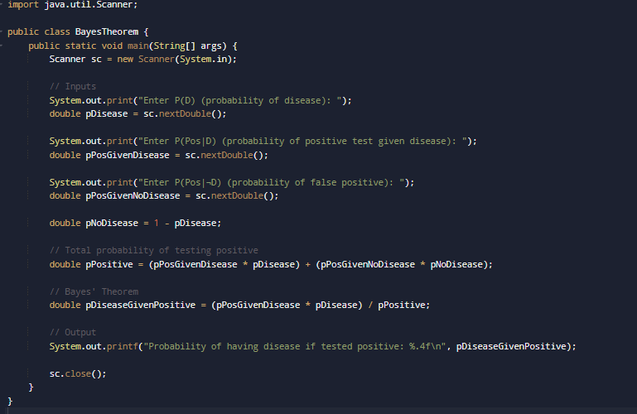

Output –

Github Link –

git@github.com:LavanyaGangaSani-05/DATA-SCIENCE.git​